The future of Mobile Technologies

The past and present versions of the two most popular mobile phone operating systems.

The past of mobile technologies:

**IOS: Android**

iPhone OS 1 Android 1.0

iPhone OS 2 Android 1.1

iPhone OS 3 Cupcake

iOS 4 Donut

iOS 5 Eclair

iOS 6 Froyo

iOS 7 Gingerbread

iOS 8 Honeycomb

iOS 9 Ice Cream Sandwich

Jelly Bean

KitKat

Lollipop

Marshmallow

**Replacement of your wallet and keys with your smartphone**

With the advent of apple pay and samsung pay, paying for things have never been easier. The ability to pay with your phone is granted and can be connected straight to your bank through this method. Apple have also released a system that allows an iPhone owner to open and lock their front door with an app, removing the need for a set of house keys. This could also be used for car doors when the technology advances. Finger print recognition is also becoming more common in the latest phones, retinal recognition may also become something that rises in popularity. All these points add to being given the ability to use mobile devices to eventually serve as an ID card and also as a way of entry, removing the need of either a wallet or keys.

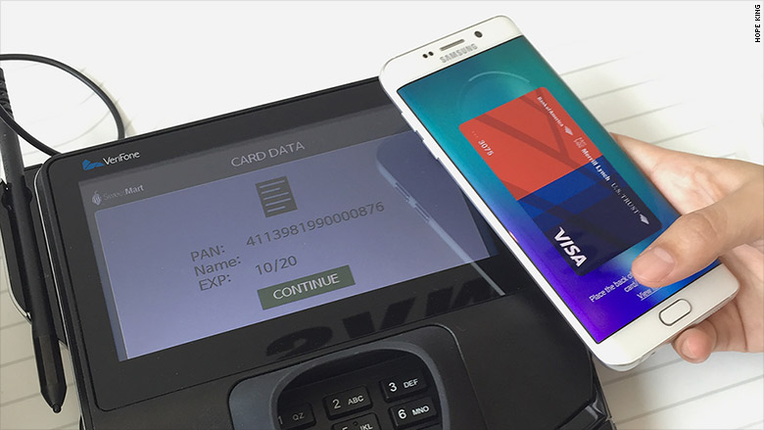

<http://money.cnn.com/2015/08/14/technology/samsung-pay/>  
<http://lowdown.carphonewarehouse.com/news/could-your-smartphone-replace-your-wallet/31247/>  
<http://www.telegraph.co.uk/sponsored/technology/4g-mobile/news/11150957/contactless-payment-phone-smartwatch.html>